Module 5 Critical Thinking Assignment

Nathan Rogers
Colorado State University Global
Course Code: CSC506
Professor Farr
05/18/2025

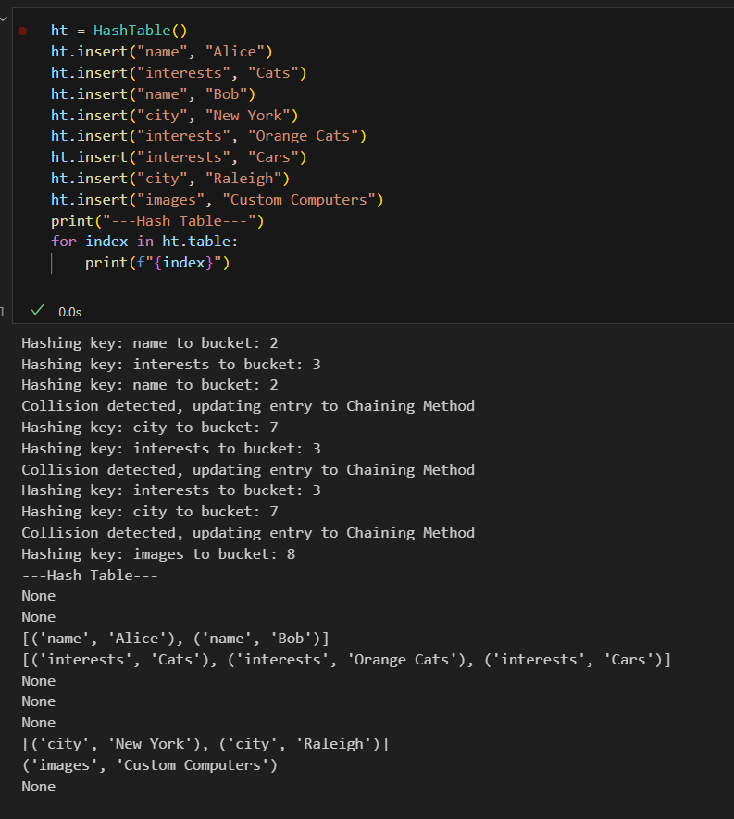

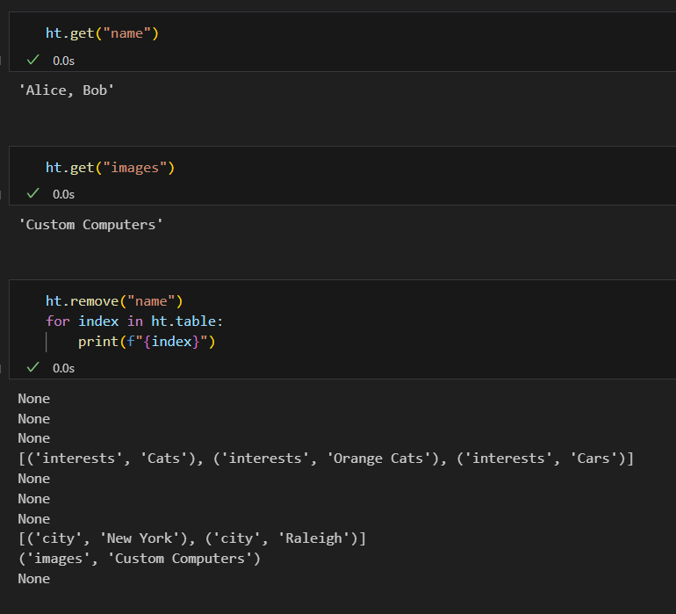

Introduction
For this critical thinking assignment, we were asked to “Tackle the problem of optimizing a social media platform's content recommendation system using hash tables, considering the immense user data and real-time updates.”.
Analysis
When browsing different social media platforms, each one has their own “algorithm” in which the app will display content that aligns with personal interests, other liked content, and viewed content, all in hopes to show similar content to keep you interested. For this to work seamlessly, the app must be able to access data quickly. This is where a hash table can be utilized. Hash tables have constant-time (O(1)) lookups meaning recommendations or content suggestions can be generated instantly based on user interactions, preferences and or browsing history.
Speaking of browsing history and preferences, we must consider storage of data within the hash table. Take TikTok as an example. Interests can be gauged off searching of a user, topic, or any other keywords. These searched keywords can be used as keys in our hash table. Collision will likely occur when searching for the same keywords but getting different results, such as the name of a user. The user can then watch their content and thus we can add entries such as (“name”, “Tyler1274”) and (“name”, “Spencer_01”) to the hash table as interests. The algorithm can then select content from these users to show without the user following these people directly. However, when viewing a lot of different content from many people these buckets could grow to be very large and potentially slow down direct lookup times. This could make the data access time grow from constant-time (O(1)) to linear-time (O(n)).

The purpose of this program was to better understand hash tables for quick data access. Hashing is widely used across many different platforms. Hashing is actually very similar to caching, in which data recently accessed or important data needed again using quick lookups. However, it does appear that hashing allows for more organized and grouped data compared to a caching system. I was able to use a similar way of thinking to implement this hash table example. Hash tables are certainly easier to implement than caches.
The one difficulty I did have during this implementation was adding collision detection and handling. Since hashing uses key-value pairs I had to implement type checking to take a single entry to a multi-entry bucket. This meant there were three conditions: insert into a bucket with a list, insert into an empty bucket, and a collision into a bucket that had the same key and an existing entry.
When referencing the textbook, I noticed that the python example includes a typecast of the hash integer output to an absolute value. “HashTable's hashKey() method uses Python's built-in hash() function. hash() may return a negative integer, but a non-negative integer is needed to compute a bucket index. So hashKey() returns the absolute value of the integer returned from hash().” (zyBooks, 5.10 Python: Hash tables). While in theory this makes sense, having a positive integer to use as an index into a list, in practice I encountered an issue where one set of entries (key = “city”) was omitted from being entered into the hash table upon changing the hash output to an absolute value. When removing the absolute value cast, I got the (key = “city”) entries back. I am unsure if this is a bug within the built-in hashing function or if this is a bug within my own code. Everything seems to work just fine without the absolute value cast, so this is why I am unsure of the true source of the bug.

References
zyBooks. (n.d.). 5.10 Python: Hash tables. In CSC506: Design and Analysis of Algorithms. essay. Retrieved May 13, 2025, from https://learn.zybooks.com/zybook/CSC506-1_10/chapter/5/section/10.
zyBooks. (n.d.). 5.1 Hash tables. In CSC506: Design and Analysis of Algorithms. essay. Retrieved May 13, 2025, from https://learn.zybooks.com/zybook/CSC506-1_10/chapter/5/section/1.

